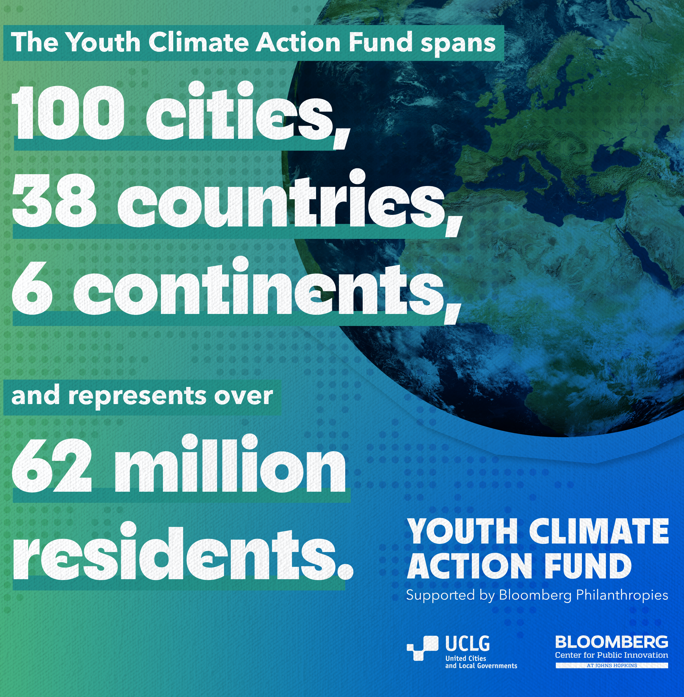

THE HON. SAMUEL PYNE, MAYOR OF KUMASI, ANNOUNCES PARTNERSHIP BETWEEN THE KMA AND BLOOMBERG PHILANTHROPIES' YOUTH ACTION FUND, AIMED TO ACTIVELY ENGAGE YOUNG PEOPLE IN DRIVING CLIMATE-RELATED SOLUTIONS FOR THE CITY.

In a significant stride towards combating climate change, Hon. Samuel Pyne today, 22ND May, 2024, has announced Kumasi's participation in the Youth Climate Action Fund by Bloomberg Philanthropies. This initiative, aimed at young people between the ages of 15 to 24, will equip 100 Mayors worldwide with the resources necessary to develop and implement urgent climate solutions in their respective cities, spanning 38 countries across six continents, representing over 62 million residents.

As part of this program, Kumasi will receive $50,000 to distribute as microgrants to fund a groundswell of youth-led climate initiatives. These projects may range from tree-planting and public education campaigns to recycling and waste reduction initiatives, as well as involvement in mitigation planning and preparedness programs. Such efforts will significantly contribute to community goals, including meeting decarbonization commitments and reducing consumption-based emissions.

It is noteworthy that, cities that promptly respond to the climate crisis and commit the initial $50,000 within six months, will receive an additional $100,000 to support more youth-driven projects over the course of one year.

In this regard, I, therefore, implore Young residents ages 15 - 24 years to visit the kma.gov.gh and Metro. Planning Unit to learn more about the Youth Climate Action Fund, supported by Bloomberg Philanthropies, and how to submit ideas for the opportunity to receive funding.

The KMA) eagerly anticipates innovative proposals from young, talented individuals to help propel our collective efforts towards addressing and mitigating the pressing issue of climate change.

